Perpendicular Line Segments
# Source: AI Source: Provided by: [Data Path: Persons Table -> ID Column: 1, Name_En Column: Motasem Essam] -> From: [ChatGPT] on [7/25/2026]
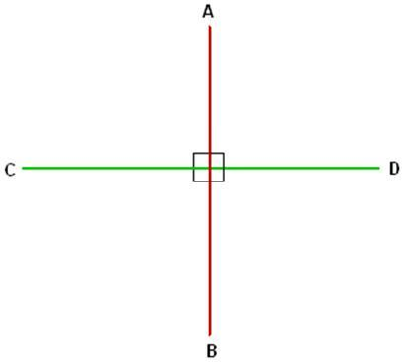
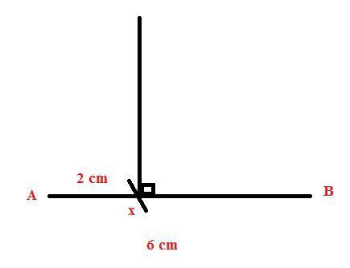
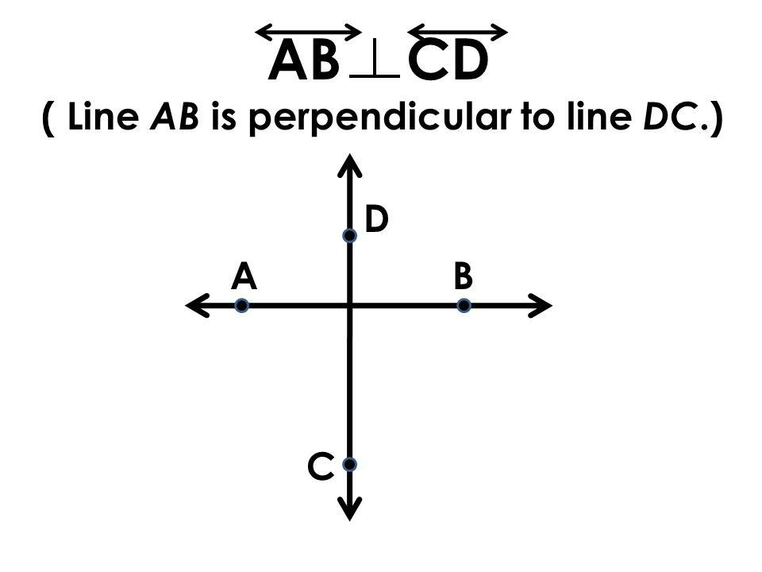
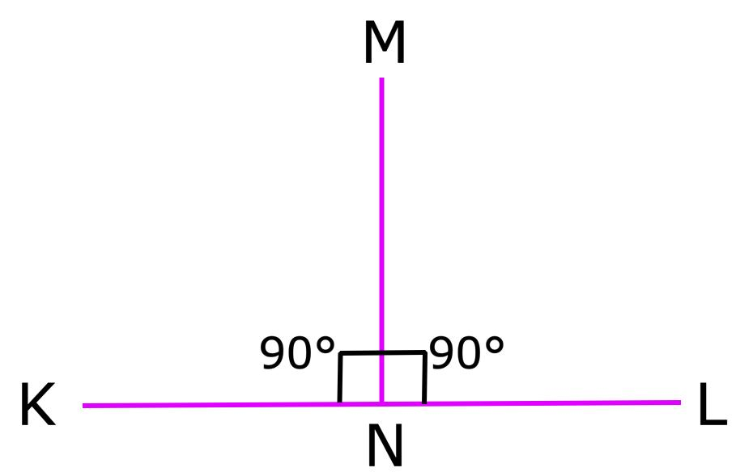
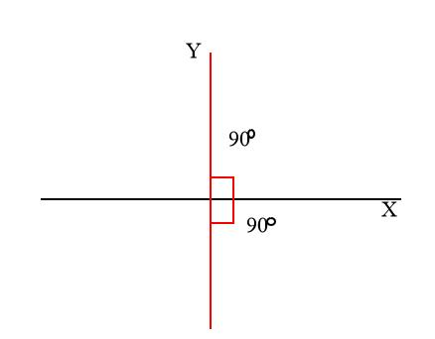

Definition
# Source: AI Source: Provided by: [Data Path: Persons Table -> ID Column: 1, Name_En Column: Motasem Essam] -> From: [ChatGPT] on [7/25/2026]
Perpendicular Line Segments are two finite line segments that intersect at a right angle (90°). They share a common point where they meet, and the angle formed between them is exactly 90 degrees.
Unlike perpendicular lines, perpendicular line segments have finite lengths and two endpoints.

Characteristics
# Source: AI Source: Provided by: [Data Path: Persons Table -> ID Column: 1, Name_En Column: Motasem Essam] -> From: [ChatGPT] on [7/25/2026]
Perpendicular line segments:
- Have two endpoints each.
- Have finite measurable lengths.
- Intersect at exactly one point.
- Form a 90° angle.
- May be horizontal and vertical, or both oblique.
- Have negative reciprocal slopes (for non-vertical segments).

Illustration
# Source: AI Source: Provided by: [Data Path: Persons Table -> ID Column: 1, Name_En Column: Motasem Essam] -> From: [ChatGPT] on [7/25/2026]
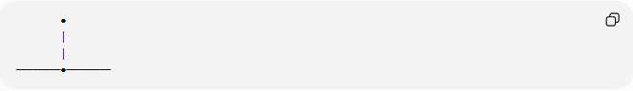
●
│
│
────────●────────
The two segments intersect at a right angle.

Mathematical Representation
# Source: AI Source: Provided by: [Data Path: Persons Table -> ID Column: 1, Name_En Column: Motasem Essam] -> From: [ChatGPT] on [7/25/2026]
Perpendicularity is represented by the symbol:
$$\overset{‾}{AB}⊥\overset{‾}{CD}$$

Coordinate Geometry
# Source: AI Source: Provided by: [Data Path: Persons Table -> ID Column: 1, Name_En Column: Motasem Essam] -> From: [ChatGPT] on [7/25/2026]
Slope Relationship
If two non-vertical line segments have slopes:
$$m_{1}$$
and
$$m_{2}$$
they are perpendicular when:
$$m_{1}m_{2}=-1$$
or equivalently,
$$m_{2}=-\frac{1}{m_{1}}$$

Example
Segment 1
$$A\left(1 , 2\right), B\left(5 , 4\right)$$
Slope:
$$m_{1}=\frac{4-2}{5-1}=\frac{1}{2}$$
Segment 2
$$C\left(3 , 6\right), D\left(1 , 2\right)$$
Slope:
$$m_{2}=\frac{2-6}{1-3}=2$$
Since
$$\frac{1}{2}×2=1$$
these are not perpendicular.
A perpendicular segment should have slope:
$$m=-2$$

Horizontal and Vertical Segments
A horizontal line segment and a vertical line segment are always perpendicular.
Example:
Horizontal:
$$A\left(2 , 4\right), B\left(8 , 4\right)$$
Vertical:
$$C\left(5 , 1\right), D\left(5 , 7\right)$$
These segments intersect at:
$$\left(5 , 4\right)$$
forming a right angle.

Properties
# Source: AI Source: Provided by: [Data Path: Persons Table -> ID Column: 1, Name_En Column: Motasem Essam] -> From: [ChatGPT] on [7/25/2026]
Perpendicular line segments:
- Intersect at one point.
- Form four right angles.
- Have finite lengths.
- Can have equal or different lengths.
- Horizontal and vertical segments are always perpendicular.

Examples
# Source: AI Source: Provided by: [Data Path: Persons Table -> ID Column: 1, Name_En Column: Motasem Essam] -> From: [ChatGPT] on [7/25/2026]
Examples of perpendicular line segments include:
- Adjacent sides of a rectangle.
- Adjacent sides of a square.
- The corner of a book.
- A wall meeting the floor.
- Window frame edges.

Applications
# Source: AI Source: Provided by: [Data Path: Persons Table -> ID Column: 1, Name_En Column: Motasem Essam] -> From: [ChatGPT] on [7/25/2026]
Perpendicular line segments are used in:
- Plane Geometry
- Coordinate Geometry
- Engineering
- Architecture
- Construction
- Surveying
- CAD (Computer-Aided Design)
- Technical Drawing
- Computer Graphics
- Robotics

Advantages
# Source: AI Source: Provided by: [Data Path: Persons Table -> ID Column: 1, Name_En Column: Motasem Essam] -> From: [ChatGPT] on [7/25/2026]
Studying perpendicular line segments helps to:
- Construct right angles.
- Design accurate structures.
- Solve geometric proofs.
- Create engineering drawings.
- Analyze coordinate geometry.

Limitations
# Source: AI Source: Provided by: [Data Path: Persons Table -> ID Column: 1, Name_En Column: Motasem Essam] -> From: [ChatGPT] on [7/25/2026]
Perpendicular line segments:
- Must intersect.
- Form exactly a 90° angle.
- Exist only between their endpoints.

Comparison with Related Objects
# Source: AI Source: Provided by: [Data Path: Persons Table -> ID Column: 1, Name_En Column: Motasem Essam] -> From: [ChatGPT] on [7/25/2026]
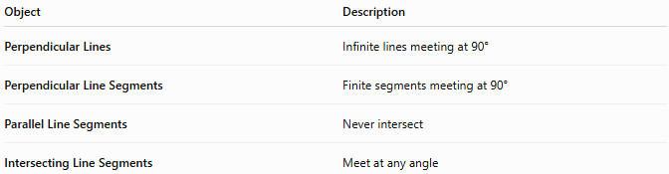
Object | Description
Perpendicular Lines | Infinite lines meeting at 90°
Perpendicular Line Segments | Finite segments meeting at 90°
Parallel Line Segments | Never intersect
Intersecting Line Segments | Meet at any angle

Key Points
# Source: AI Source: Provided by: [Data Path: Persons Table -> ID Column: 1, Name_En Column: Motasem Essam] -> From: [ChatGPT] on [7/25/2026]
- Perpendicular Line Segments intersect at:
$${90}^{∘}$$
- They are represented by:
$$\overset{‾}{AB}⊥\overset{‾}{CD}$$
- Non-vertical perpendicular segments satisfy:
$$m_{1}m_{2}=-1$$
- Horizontal and vertical segments are always perpendicular.
- Perpendicular line segments are widely used in geometry, engineering, architecture, construction, CAD, surveying, and technical drawing.

Conclusion
# Source: AI Source: Provided by: [Data Path: Persons Table -> ID Column: 1, Name_En Column: Motasem Essam] -> From: [ChatGPT] on [7/25/2026]
Perpendicular Line Segments are finite straight segments that intersect to form a right angle of exactly 90°. Like perpendicular lines, they satisfy the negative reciprocal slope relationship in coordinate geometry (except for horizontal and vertical cases), but they are bounded by two endpoints and have measurable lengths. Perpendicular line segments are fundamental in plane geometry, coordinate geometry, engineering, architecture, construction, surveying, CAD, technical drawing, robotics, and computer graphics, where right-angle relationships are essential for accurate measurement, structural stability, and geometric design.

